|  |  |  |  |  |  |
| --- | --- | --- | --- | --- | --- |
| Date | 7-Dec-22 | | | Tester Name | Jessie Liu |
| Environment | Select Environment | | | Login used |  |
| Operating System | Select OS | Version: | Update: | | |
| Software Used | Select Software | Version: | Update: | | |
| Select Software | Version: | Update: | | |
| Release version |  | | | | |
| Title | Enrolment | | | | |
| Test Type | Regression | | | | |
| Test Scenario | Skeleton member enrolment | | | | |
|  |  | | | | |
| Expected Results |  | | | | |
| Pass/Fail | Pass | | | JIRA# | N/A |

Describe your steps with screenshots:

1. Upload SIN contribution for the member who doesn’t exist in Penfax

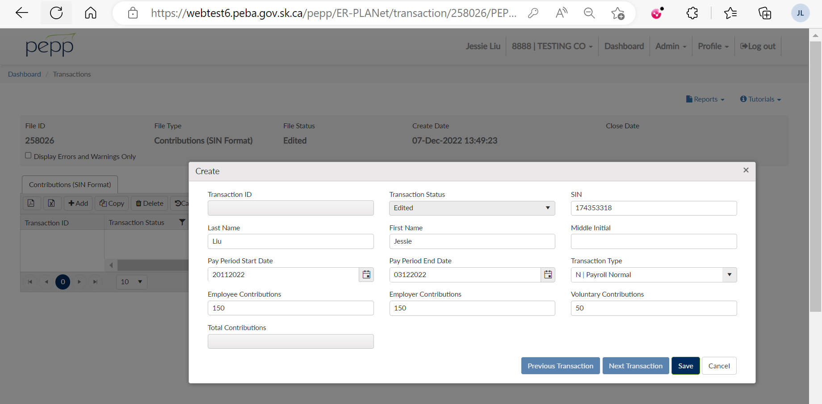

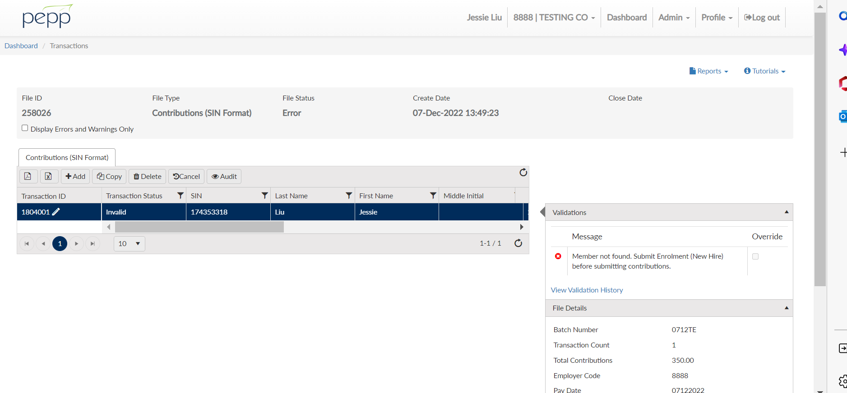

1. Upload EEID contribution

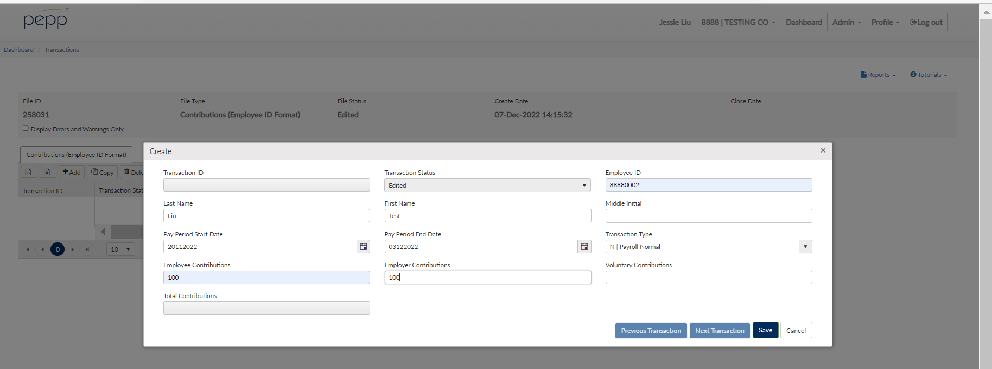

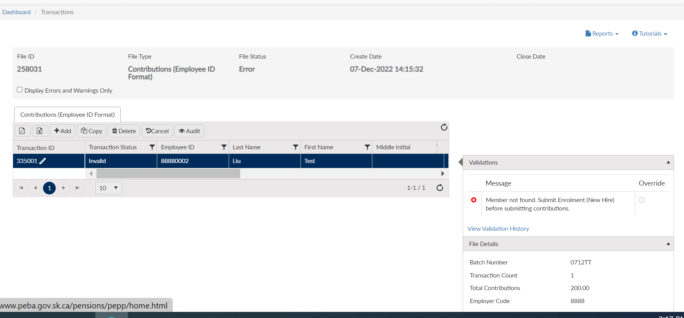

1. Enrolment the member

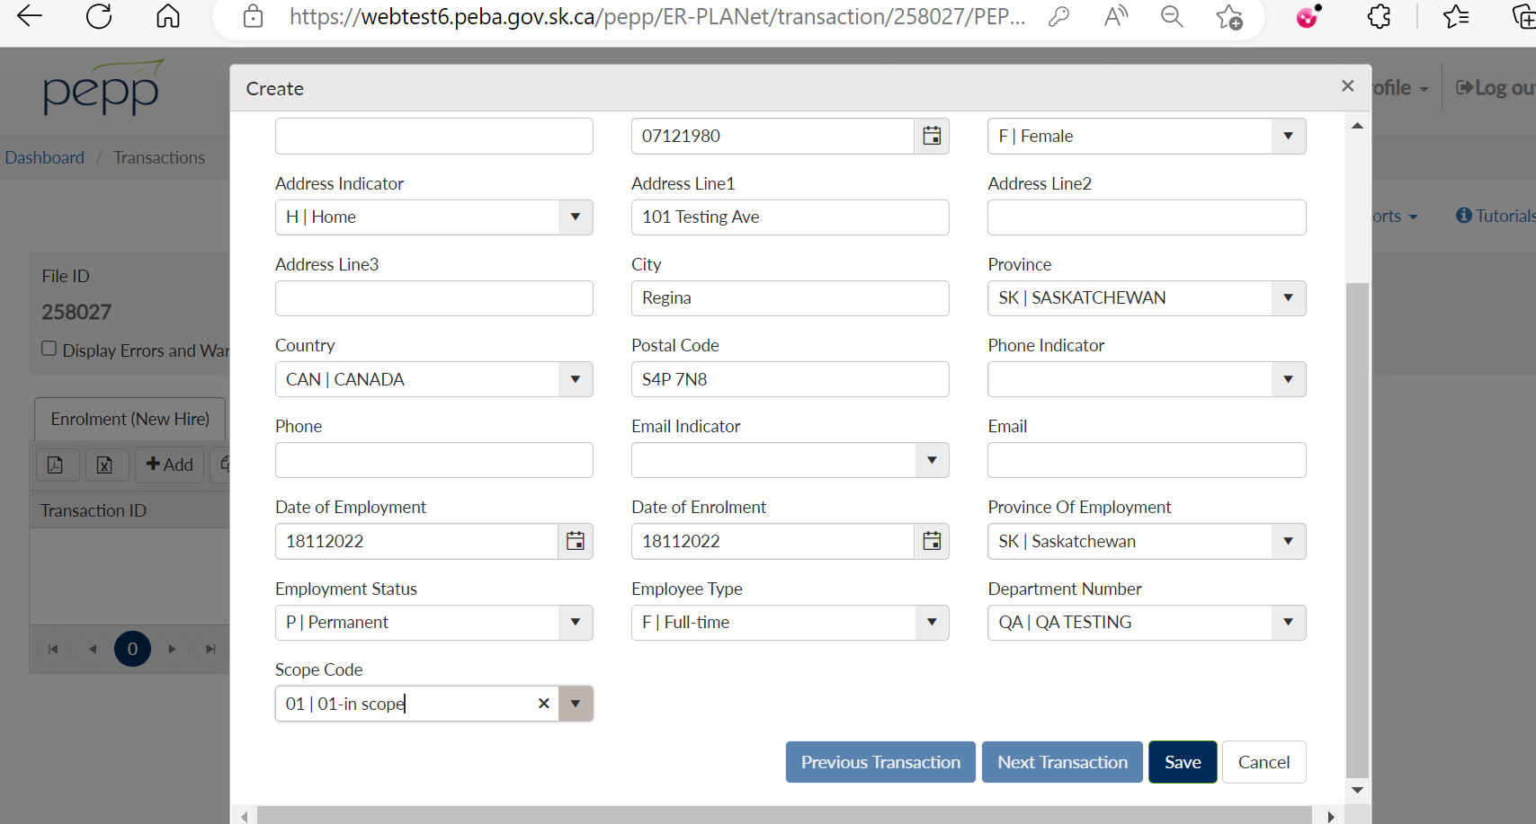

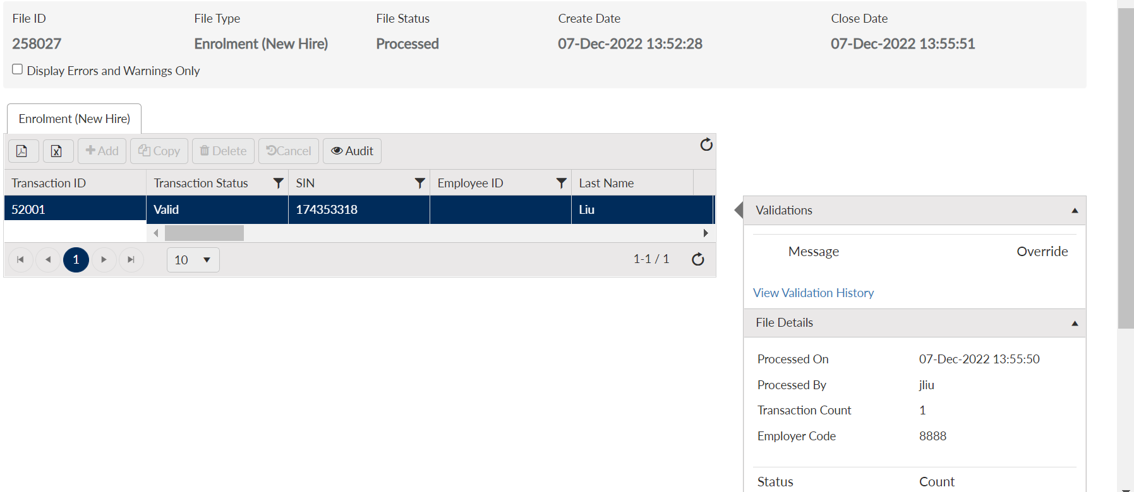

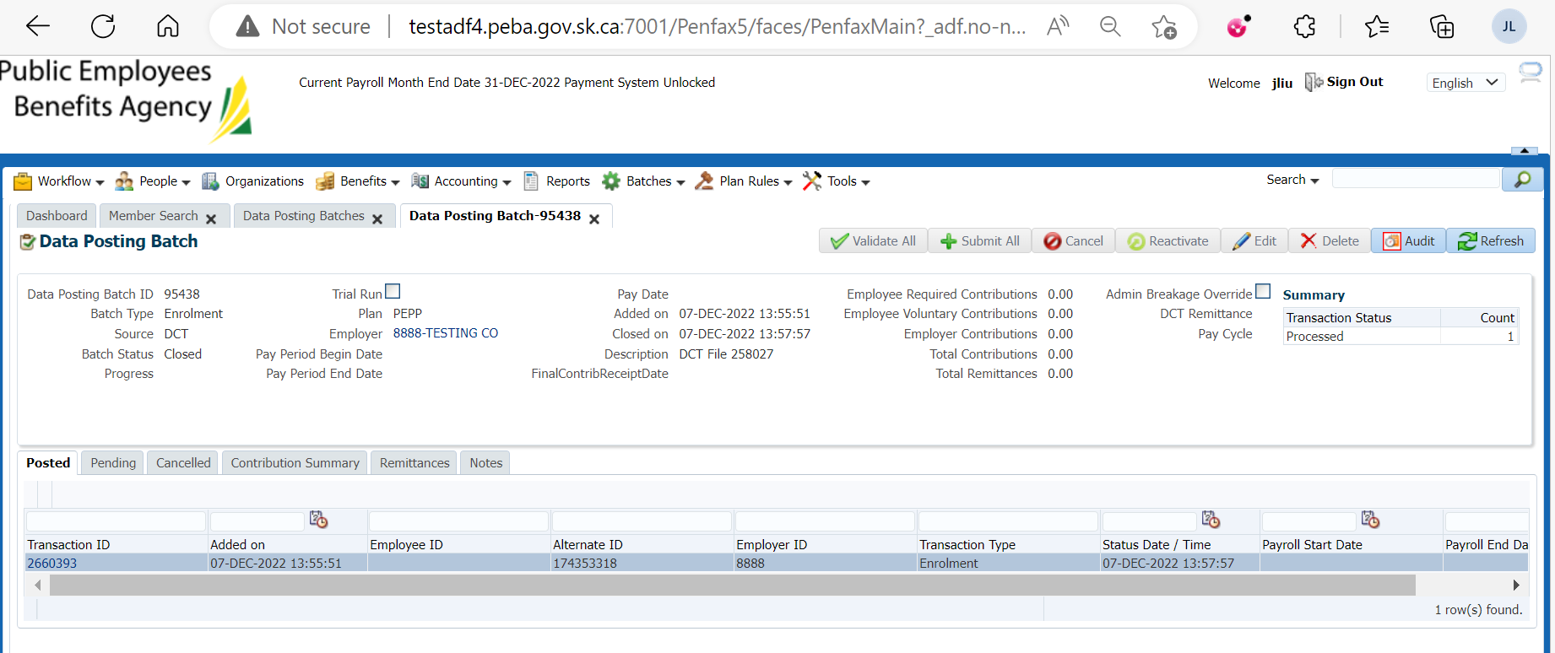

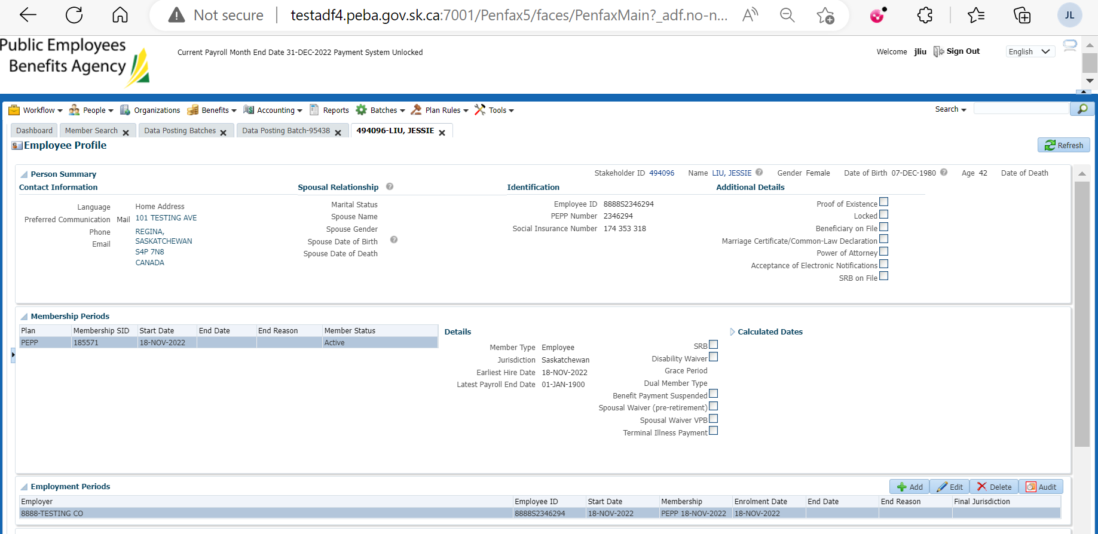

1. Remit the contribution

